**Catering Industry**

**Stakeholders**

|  |  |
| --- | --- |
| **ACTOR/Stakeholder** | **What they can do on the software created** |
| Employees | Should be able Order Meal  Register for payroll deduction  Provide feedback |
| Menu Manager | Changing menu in requirement |
| Canteen Manager | Updating menu which items are available |
| Meal deliverer | Deliver the lunch to employees  Update the delivery status once delivered |
| Payroll Department | Observing the employee day wise bills |
| Management | Observe if there is any issues |

**Problem Definition and Solution**

* A lot of time is wasted by employees on going to the canteen to eat lunch
* Employees don’t get choice of food
* time consumed in mobility and eating time in out to café
* Reduction of food wastage

**Advantages and Objectives**

Advantages of the Canteen Ordering System:

* A system would save considerable time to those employees who use the service.
* It would increase the chance of them getting the food items they prefer.
* This would improve both their quality of work life and their productivity.
* The food wastage will be reduced.
* This will reduce the cost.

**Objectives:**

**Business Objective 1:**

Reduce canteen food wastage by a minimum of 30% within 6 months following first release.

Scale: Value of food thrown away each month by examining the canteen inventory

* Previous - 25% wasted
* Must plan for: Less than 15%

**Business Objective 2:**

Reduce canteen operating costs by 15% within 12 months, following initial release.

**Business Objective 3:**

Increase average effective work time by 30 minutes per employee per day, within 3 months.

**Business Objective 4:**

By making the ordering process automated and by delivering the food to the user's workstation, the canteen will be able to operate with lesser manpower.

**Existing System**

* There is no existing system. Time consuming, complex, manual, requires manpower , lot of food wastage.

**Proposed System**

What is the proposed solution or system? Mention in points how the system itself will be for the user.

The proposed system is a software system “Online ordering system” for tracking and ordering purpose.

|  |
| --- |
| - **Pre-ordering**: Employees can place orders up to 12 hours in advance. |
| - **Real-time Menu Updates**: Live updates on available food items and specials. |
| - **Delivery Scheduling**: Options for selecting delivery times within a specified window. |
| - **Payment Integration**: Secure payment options within the platform. |
| - **Feedback Mechanism**: Post-meal feedback and ratings for continuous improvement. |

**Scope using *use case diagram* (UML)**

Create a use case diagram including all the actors and processes for an end to end process of the system.

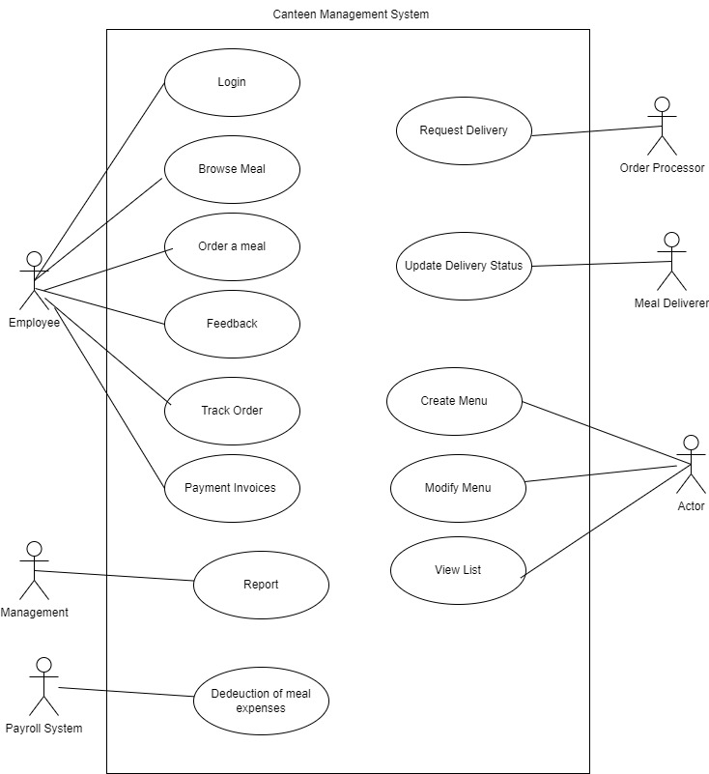

**Scope using *context diagram***

Depict the scope using Context diagram.

**In Scope**

Login

Place an order

Delivery

Integration to Payroll—Sync with salary deduction

Feedback

Manage Orders

Menu Options

Create/Edit/Delete Menu

Pre Order

Status of Order

Track Order

Contact

Reports

Log out

**Out of Scope**

* Inventory Managemnt
* Payment will not be thru any credit card , debit card , wallet,COD
* Delivery of food will be within the campus only
* Mobile App

**Activity Diagram for the System:**

Create an activity diagram for the system.

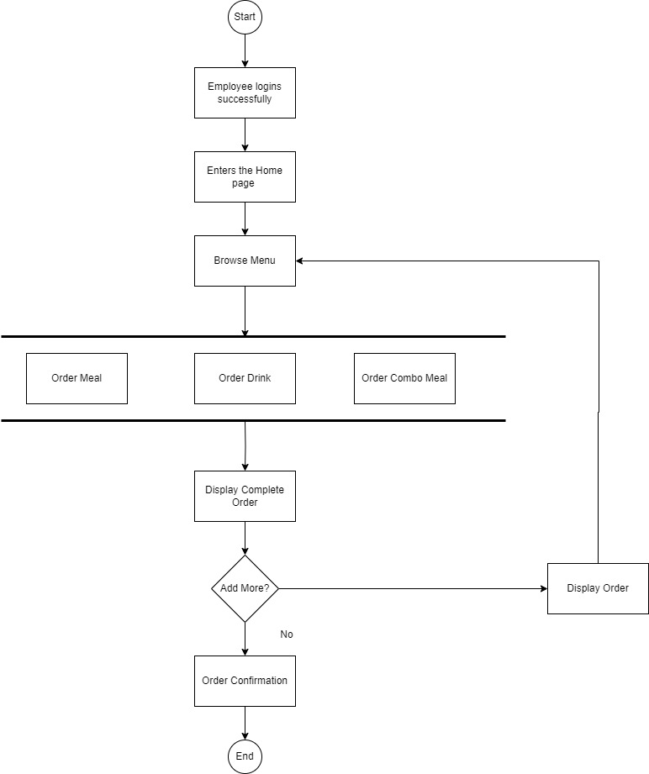

**Functional Requirements**

* Write down all the functional requirements for the system.
* Menu Creation
* Menu Deletion
* Menu Editing/updation by menu manager
* Order creation by employee : Menu availability within office hours
* Order confirmation
* View Orders by order processor
* Meal delivery Closure in the system
* Feedback submission by employees
* Payroll deduction facility to be offered to users
* Payroll deduction calculations
* Reports generation
  1. Which dishes are the most popular?
  2. How many employees are using the system?
  3. Satisfaction of the employees on using the system. This should be tracked on the basis of feedback submitted by the employees.
  4. Sales for each day
  5. Total monthly earnings
  6. Order forecasting i.e. a prediction of which items will be ordered and when they will be ordered.

**Nonfunctional Requirements**

* Write all the nonfunctional requirements for the system.
* **System Requirement:**
  + Scalability and performance:
  + This canteen ordering system is required to support a volume of 1500 employees ordering. the web pages should be light and render fast.
* **Environments**
  + We are going to be creating and maintaining the program in Java. We chose Java because it will not change much over time, and if we make it well, there will be very little maintenance to be done on the code.
* **Usability:**
  + The screens should be self-explanatory and very user friendly. Management would not want employees not ordering from the system as they cannot understand the screens and data fields on screen.

